Sussex NHS Commissioners
COVID-19 Vaccination Programme

Increasing COVID-19 Vaccination uptake
Small Grants

Invitations for Expressions of Interest

Increasing COVID-19 vaccination - small grants

Background

Since the start of the COVID-19 Vaccination programme across Sussex, nearly one million vaccines have been delivered to our communities and health and care workforce. The roll out of this programme has been based on a co ordinated approach, supported by effective communications to partners and the public.
Nationally, the vaccination programme has been rolled out in Phase 1 to cohorts 1-9 (see below):
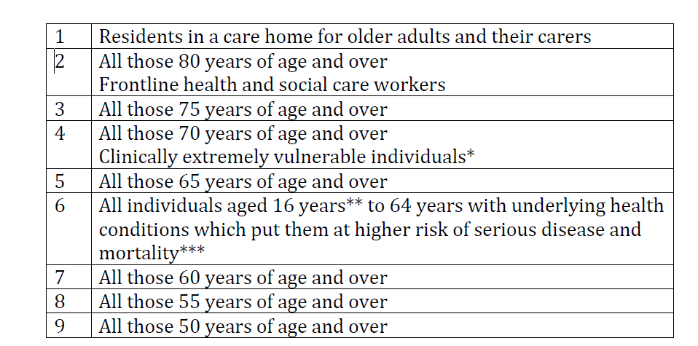
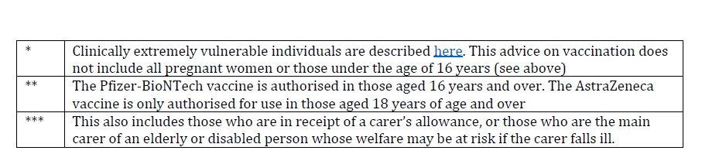
Phase 2 is now beginning; this should be accompanied by continued efforts to extend coverage among those prioritised in phase 1 but who remain unvaccinated, and to complete delivery of second doses to all those given first doses in phase 1.
The offer of vaccination in Phase 2 will be aged based, starting with the oldest adults first and proceeding in the following order:
- all those aged 40 to 49 years (note that aged 45-49 is underway)
- all those aged 30 to 39 years
- all those aged 18 to 29 years

In individuals aged 18 to 49 years there is an increased risk of hospitalisation in males, those from certain ethnic minority backgrounds, those with a body-mass index (BMI) of 30 or more (obese or morbidly obese), and those experiencing socio-economic deprivation.

Data on vaccination uptake so far shows that there are some geographical areas and some communities for whom the uptake of the vaccine is lower than average. This is for a variety of reasons, some of which can be mitigated and supported through targeted communications including those in alternative formats, outreach to neighbourhoods and solution focussed work with community members.

Aim of the small grants scheme
To help support the increase of vaccination uptake, small grants will be offered to assist with neighbourhood based activity, across communities of interest or relating to people particularly at risk of serious illness if they contract COVID-19.
The types of activities that may be eligible are:
- Development of community based communications
- Hyper local buddying schemes to support people in accessing vaccination
- Targeted work with local groups to increase awareness of facts about vaccine and dispel myths
- Making community based videos and distributing appropriately

(The above are examples- innovative approaches are welcomed.)

Targeted communities and groups
Applications are invited from those working to support any of the following:
- South Asian Communities
- Black African communities
- Chinese communities
- People living in identified areas of deprivation
- Adults with learning disabilities
- Gypsy, Roma and Traveller communities
- Those with physical or sensory disabilities
- Those who are clinically vulnerable or who live with long term health issues
For groups outside of the above list, applications are also welcome; however you will be asked to provide information/insight on these groups/communities having a lower than average uptake of vaccination.

Financial details
Grants of up to £5,000 will be awarded.
Applicants must be constituted organisations with a bank account, or with an agreed organisation to hold funding.

Monitoring and oversight
Those receiving grants will be asked to provide a short summary of activity and the impact this has had. Note that there will not be a need for funded projects to demonstrate statistically an increase in uptake or vaccination.
Oversight will be through a key contact in the CCGs’ Public Involvement Team.

Timescales
Applications are invited from 19th April 2021; the grants scheme will be open until end July 2021, in order to respond to changing data on uptake.

Application

We can only accept applications from fully constituted VCS organisations; however we would encourage smaller unconstituted groups to work in partnership with larger groups, recognising the value that smaller groups can bring to this work, or to agree an appropriate organisation to hold funds.

Which neighbourhood/area or community do you work with? ( Up to 200 words)

This may be a small very local area, a neighbourhood/village/town, or a community such as a group of Chinese residents, a Black African community, etc

How do you know that your group or community have low vaccine uptake? (up to 300 words)

Tell us why you need support – for example, “data is showing low uptake in my area”, “many of my community members say they don’t want to have the vaccine as they are worried about side effects”, “many of this community don’t understand English and haven’t got the information in a way they understand”

What is your proposal? (up to 750 words)
Tell us what you plan to do, who with, and when

What information and/or support might you need to make your project successful? (Up to 200 words)
For example, you may need information about the vaccine

How will you know you have been successful? (Up to 300 words)

For example “community members report they have had the vaccine”, “people tell us that the fact sheet was very helpful and they are happy to book their vaccine”, “everyone in my road who is eligible will have been vaccinated”

How much money do you want to apply for?
You can apply for up to £5,000

Will this be held by your organisation? Yes/No

If no, please tell us who will hold this money for you

If you have any questions, please contact

Jane Lodge, Associate Director of Public Involvement jane.lodge1@nhs.net (07771 871536)
Or
Antonia Bennett, Public Involvement Lead, antonia.bennett1@nhs.net (07887 274637)

Please send completed submissions to Jane Lodge, as above. All applications must be received by 31st May 2021; funding will be allocated on a rolling basis, as applications are received and agreed.

